Date: **March 5th, 2018**

Name: **Hasana Chaudry**

Instructor: **Masooma Pirbhai**

Project: **Matlab – Activity 1**

Course: **Electric and Magnetic Fields**

1. 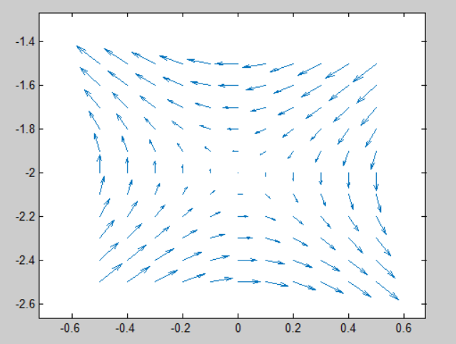
2. 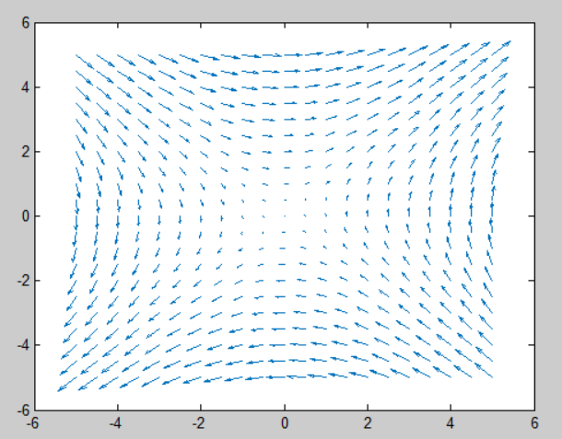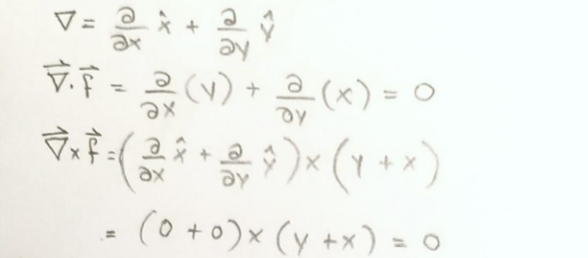

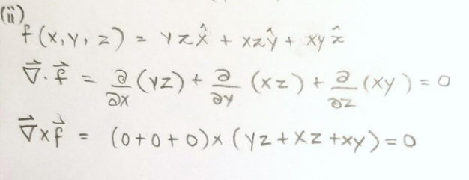

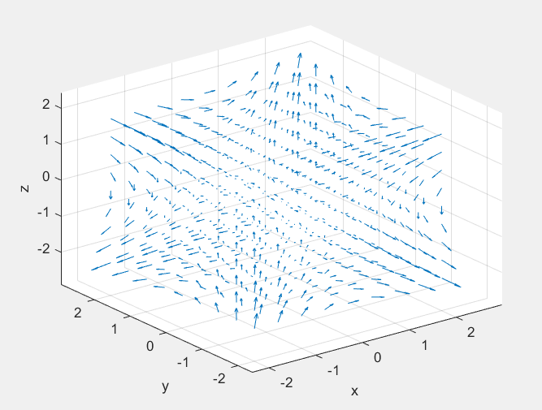

1. 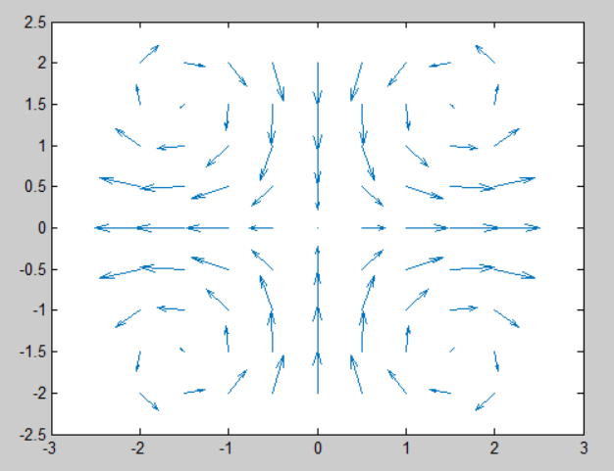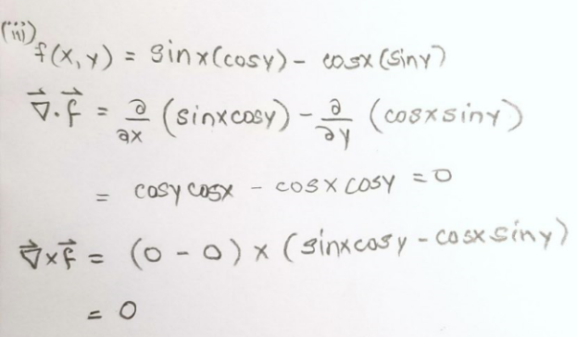
2. .m file emailed. No physical attachments.

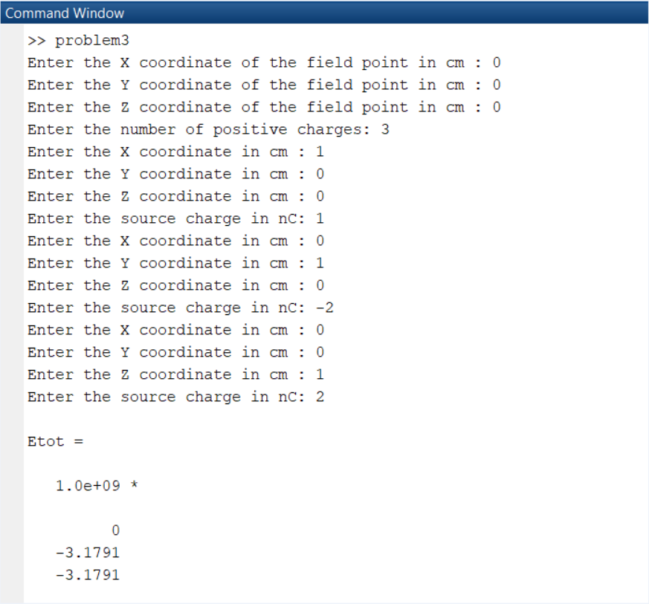

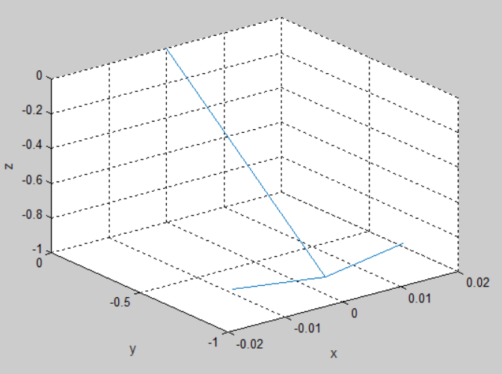

1. .m file emailed. No physical attachments.
2. .m file emailed.